Wreath Hardware Instructions

REV 01 – 18 Dec 17

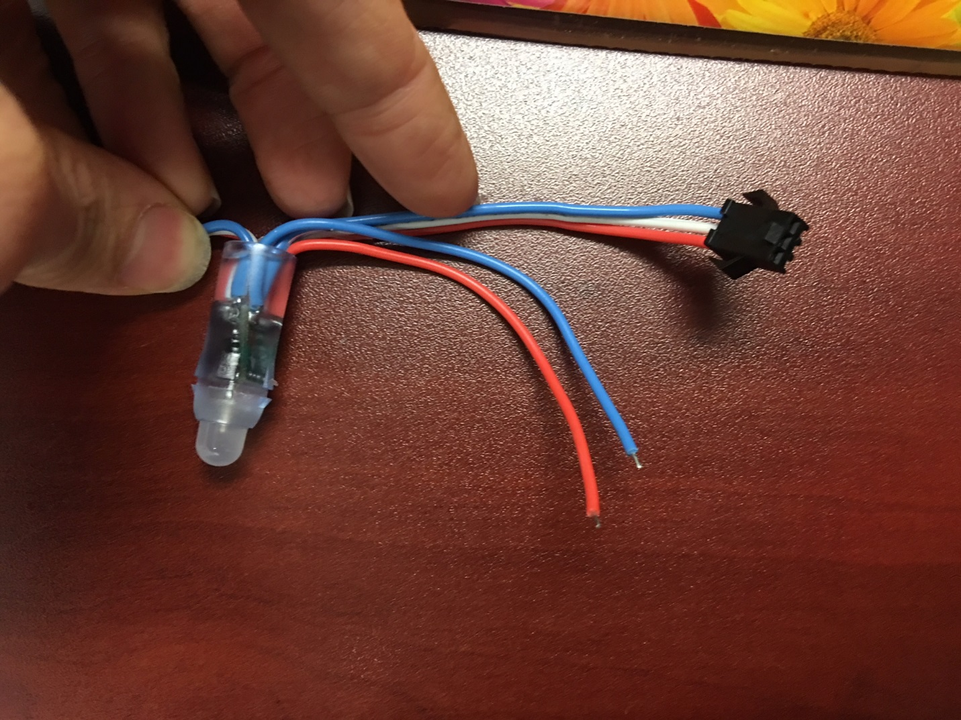

Female Connector

LED 0 is the one closest to the female connector

Holes for Hanging Wire

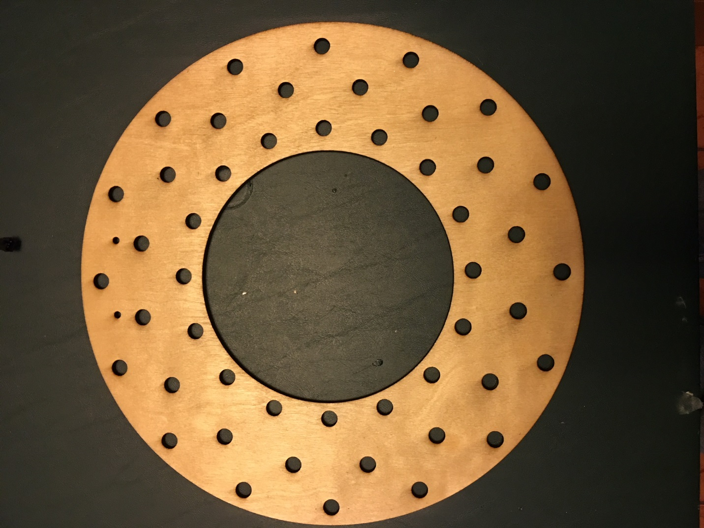

15

0

47

31

16

32

Backside View Shown – Insert the LED’s starting with #0 up to #47

* Cut off the female connector
* Strip and solder the 3 wires that went to the female connector to the Arduino Nano as follows:
  + Red – 5V
  + Blue – GND
  + White – D6
* Use the AC adaptor barrel adaptor and connect the wires as follows:
  + Red wire to + screw
  + Blue wire to – screw
* Cap off the two flying wires on the far end (end with male connector still on it) of the LED strand with heat shrink as they are not used.
* Glue the male connector at the far end to the backside of the wreath as it is not used.

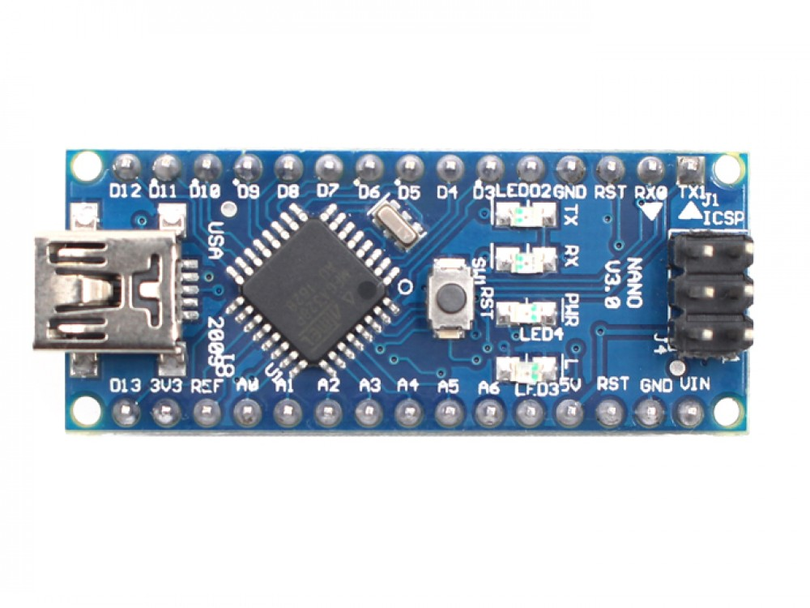

Red Wire

Blue Wire

White Wire

Suggestions:

* Put a label next to the barrel connector that says ”5VDC Center + Only”
* Put a label on the AC adaptor that says it’s for the wreath